[ARTICLE TITLE]
[Title Font: HoloLens MDL2 Assets, Size: 18, bold, Center Alignment]
First author ¹, Second author ², Third Author ³
[Author Font: HoloLens MDL2 Assets, Size: 11, bold, italic, Center Alignment]
¹field Affiliation, Address, City and Postcode, Country
²field Affiliation, Address, City and Postcode, Country
ABSTRACT
[Abstract Font: HoloLens MDL2 Assets, Size: 11, bold, italic, justify]
Soil is defined as a thin layer of the earth'scrust, which serves as a medium for thgrowth of plants. It is anatural body ofanimal, mineral, and organic constituents differentiated into horizons of variable depth, which differ from the material below in morphology, physical makeup, chemical properties, compositions, and biological characteristics. Good soil nutrition is the solution to many of the problems afflicting agriculture. Insect pests, diseases and weeds are all directly related to poor soil health. There is an 'ideal' state of balance between the physical, chemical and biological components of the soil, at which production is maximized and pest and weed pressure is greatly reduced. This 'ideal' state is what every farmer should try to attain.
Keyword: first keyword, Second keyword, Third keyword (Most relevant to your abstract)

1. INTRODUCTION
[Font: HoloLens MDL2 Assets, Size: 11, justify]
Soil is the interface between air, water, minerals and living organisms. These are the four major components of soil and it is important to understand the contributions of these components to soil productivity and fertility. These components determine the kind and type of soils 'Soil Air' refers to the soil atmosphere; the gaseous phase of the soil that is neither solid nor liquid. 'Soil Water' or Soil Solution is the liquid phase of the soil containing dissolved salts and chemicals (ions) that are free floating
and not attached to any solid particles (mineral surfaces). 'Soil Minerals' are composed of varying amounts of sand, silt and clay. These particles are not derived from materials that are inorganic in nature. Their characteristics greatly influence soil characteristics,
behavior and management practices. 'Soil Organic' Matter (SOM) in the soil includes plant and animal residues at various stages of decomposition. Cells, tissues and substances synthesized by plant roots and soil microorganisms constitute SOM. Most cultivated top soils contain about 2-4% organic matter by weight A typical medium textured soil will have a BD = 1.25 mg/m. Soil Structure Polyhedra/Blocky Platy/Laminated Granular Aggregation : Is the arrangement of soil particles into groups in the soil like clods, prism, plates.
Soil Texture : Is the proportion of sand, silt and clay in the soil. The soil triangle helps define the texture of the soil depending onthe percentage of sand, silt and clay in the given soil. The Soil Triangle assists in determining the type of soil based on the percentage of the three constituents. Soil Structure Is the arrangement of soil
particles in the soil pedon. There are four types of soil structures. Tilth : Is the physical condition of soil as
- explained by its ease of tillage, capacity to
- support a healthy seed bed and support
- root penetration.
- water into the soil. Texture/structure of the
- soil determines the infiltration rate and
- drainage capacity and the amount of water
present in the soil. Infiltration rate in turndetermines the aeration and temperature of the soil.Porosity : Is the volume of soil occupied bpore space. The pore space of a soil is portion of soil volume occupied by air an water. The amount of this pore space I determined by the arrangement of the soi particles. In sandy soils, porosity is lo
2. TABLES
Column Heading | Column A (CX) | Column B (ST)
an entry | 233 | 348
another entry | 33 | 65756
And another entry | 3434 | 77
Table 1. An Example of Table
Cation Exchange Capacity is defined as the ability of the soil to hold onto nutrients (positivelycharged ions like- Ca2+, Mg2+, K+, NH +) and prevent them from leaching beyond the roots. The more cation exchange capacity a soil has, the more likely the soil will have a higher fertility level. When combined with other measures of soil fertility, CEC is a good indicator of soil quality and productivity. It is the amount of cations that can be held by 100g of soil units : 1milliequivalent of charge per 100g of soil. CEC ranges from < 1 meq/100g in sandy soils low in OM to > 25 meq/100g in soils
high in certain types of clay or OM. Soil OM will develop a greater CEC at near-neutral pH than under acidic conditions. Addition of organic matter will increase a soil's CEC. Soil CEC may alsodecrease with time through acidification and OM decomposition.
2.1. The CEC of soils is determined by
The amount of organic matter in soil as well as the percentage of clay. Higher the OM and clay, higher the CEC of soils, thus higher the nutrients provided in available form to plants, thus higher fertility and productivity of soils. The type of clay in the soil also determines the CEC of the soil.pH of soils
In a 'balanced' soil, Calcium accounts for about 65-70% of the CEC, Magnesium 10-15% of the CEC, Potassium about 4.5% of CEC, Sodium 2% of CEC, trace Elements 3% and Hydrogen about 10% of CEC. Ca/Mg ratio should always add up to 80% of soil CEC. The CEC also depends on the strength of adsorption of the cations. According to the adsorption ladder, Al3+ is more tightly bound to the clay particle in soil than is K+ and hence K+ is more readily available to plants than Al3+.[4]
3. BIOLOGICAL PROPERTIES OF SOIL
3.1. Biomass of Soil
It is the measure of living material in the soil including microorganisms, insects, plants and small animals. It is important in determining the potential organic matter content in soils as well as the soil health and tilth. Carbon to Nitrogen Ratio (C:N)
Carbon and Nitrogen are two key elements that are required by all organisms to complete theirlife cycle since both are used as building blocks for the organism / plant. The C:N ratio in soils ranges from 8:1 to 15:1, while in plants such as legumes, it ranges from 10:1 to 30:1, to as high as 80:1 in wheat straw.
There are two key reasons for understanding the importance of this ratio. The competition between microorganisms and plants increases when high C:N ratios are added to the soil. This leads to N deficiency in plants as explained in the graphic. The ratio helps to determine the rate of decay of residues added to the soil and hence how
3.2. Biomass of Soil
It is the measure of living material in the soil including microorganisms, insects, plants and small animals. It is important in determining the potential organic matter content in soils as well as the soil health and tilth. Carbon to Nitrogen Ratio (C:N) Carbon and Nitrogen are two key elements that are required by all organisms to complete their
life cycle since both are used as building blocks for the organism / plant. The C:N ratio in soils ranges from 8:1 to 15:1, while in plants such as legumes, it ranges from 10:1 to 30:1, to as high as 80:1 in wheat straw. There are two key reasons for understanding the importance of this ratio. The competition between microorganisms and plants increas

3.2.1. Biomass of Soil Points
The amount of organic matter in soil as well as the percentage of clay. Higher the OM and clay, higher the CEC of soils, thus higher the nutrients provided in available form to plants, thus higher fertility and productivity of soils. The type of clay in the soil also determines the CEC of the soil.pH of soils
4. AUTHOR WORK ND CHART
Soil is the interface between air, water, minerals and living organisms. These are the four major components of soil and it is important to understand the contributions of these components to soil productivity and fertility. These components determine the kind and type of soils 'Soil Air' refers to the soil atmosphere; the gaseous phase of the soil that is neither solid nor liquid. 'Soil Water' or Soil Solution is the liquid phase of the soil containing dissolved salts and chemicals (ions) that are free floating
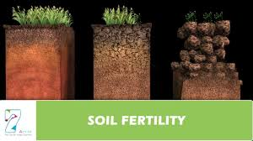
Figure 1(a) First figure (b) Second figure [Citation]
Soil is the interface between air, water, minerals and living organisms. These are the four major components of soil and it is important to understand the contributions of these components to soil productivity and fertility. These components determine the kind and type of soils 'Soil Air' refers to the soil atmosphere; the gaseous phase of the soil that is neither solid nor liquid. 'Soil Water' or Soil Solution is the liquid phase of the soil containing dissolved salts and chemicals (ions) that are free floating
Soil is the interface between air, water, minerals and living organisms. These are the four major components of soil and it is important to understand the contributions of these components to soil productivity and fertility. These components determine the kind and type of soils 'Soil Air' refers to the soil atmosphere; the gaseous phase of the soil that is neither solid nor liquid. 'Soil Water' or Soil Solution is the liquid phase of the soil containing dissolved salts and chemicals (ions) that are free floating
Soil is the interface between air, water, minerals and living organisms. These are the four major components of soil and it is important to understand the contributions of these components to soil productivity and fertility. These components determine the kind and type of soils 'Soil Air' refers to the soil atmosphere; the gaseous phase of the soil that is neither solid nor liquid. 'Soil Water' or Soil Solution is the liquid phase of the soil containing dissolved salts and chemicals (ions) that are free floating
Soil is the interface between air, water, minerals and living organisms. These are the four major components of soil and it is important to understand the contributions of these components to soil productivity and fertility. These components determine the kind and type of soils 'Soil Air' refers to the soil atmosphere; the gaseous phase of the soil that is neither solid nor liquid. 'Soil Water' or Soil Solution is the liquid phase of the soil containing
5. GRAPH AND METHODS
The amount of organic matter in soil as well as the percentage of clay. Higher the OM and clay, higher the CEC of soils, thus higher the nutrients provided in available form to plants, thus higher fertility and productivity of soils. The type of clay in the soil also determines the CEC of the soil.pH of soils
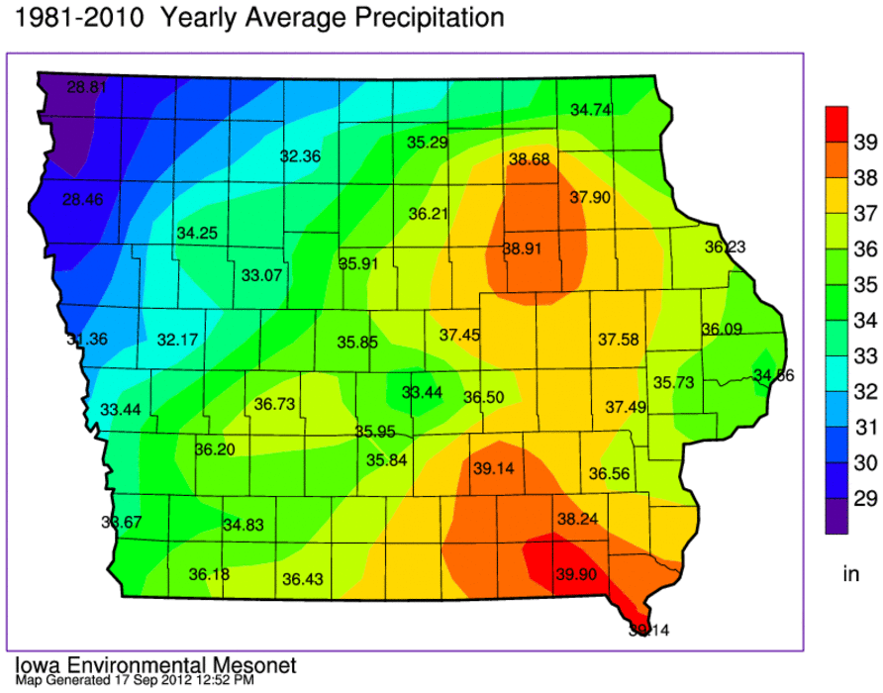
Figure 2(a) First figure (b) Second figure [Citation]

5.1. Balanced' soil
In a 'balanced' soil, Calcium accounts for about 65-70% of the CEC, Magnesium 10-15% of the CEC, Potassium about 4.5% of CEC, Sodium 2% of CEC, trace Elements 3% and Hydrogen about 10% of CEC. Ca/Mg ratio should always add up to 80% of soil CEC. The CEC also depends on the strength of adsorption of the cations. According to the adsorption ladder, Al3+ is more tightly bound to the clay particle in soil than is K+ and hence K+ is morereadily available to plants than Al3+.[4]
5.2. Organic matter
The amount of organic matter in soil as well as the percentage of clay. Higher the OM and clay, higher the CEC of soils, thus higher the nutrients provided in available form to plants, thus higher fertility and productivity of soils. The type of clay in the soil also determines the CEC of the soil.pH of soils
In a 'balanced' soil, Calcium accounts for about 65-70% of the CEC, Magnesium 10-15% of the CEC, Potassium about 4.5% of CEC, Sodium 2% of CEC, trace Elements 3% and Hydrogen about 10% of CEC. Ca/Mg ratio should always add up to 80% of soil CEC. The CEC also depends on the strength of adsorption of the cations. According to the adsorption ladder, Al3+ is more tightly bound to the clay particle in soil than is K+ and hence K+ is morereadily available to plants than Al3+.[4]
The amount of organic matter in soil as well as the percentage of clay. Higher the OM and clay, higher the CEC of soils, thus higher the nutrients provided in available form to plants, thus higher fertility and productivity of soils. The type of clay in the soil also determines the CEC of the soil.pH of soils
In a 'balanced' soil, Calcium accounts for about 65-70% of the CEC, Magnesium 10-15% of the CEC, Potassium about 4.5% of CEC, Sodium 2% of CEC, trace Elements 3% and Hydrogen about 10% of CEC. Ca/Mg ratio should always add up to 80% of soil CEC. The CEC also depends on the strength of adsorption of the cations. According to the adsorption ladder, Al3+ is more tightly bound to the clay particle in soil than is K+ and hence K+ is morereadily available to plants than Al3+.[4]
6. ACKNOWLEDGEMENT
Even though the farmer wishes to have yields at the level of 85-90% of the genetic potential, in realityhe gets lower yields (50-55%). But by expecting the full 90% yield he applies heavy fertilizers.Management and excessive use of nutrient inputs will neither boost yield nor reduce farmexpenditure.
Our system of FPRP (Fertilizer Programme Related to Production) is designed to make the farmerunderstand that the soil has an important role to play in the release of nutrients. Crops grown on poorsoil will invariably produce lower yields. Lower yields in such a situation will not be boosted by simply
increasing the fertilizer inputs. If soil correction measures are instituted, the cost of input should be inthe range of 20-30% of the final yield income. It is prudent for a farmer to analyze his soil and makethe necessary changes I improvements to maximize his soil and crop potential.
REFERENCES
Article/ Research Paper
[1] k ranaday agro, "An analytical survey of state of the art Jellyfish attack detection and prevention techniques2016.
Books
[1] k. Name. Author, crop nutriouns,” in Title of His Published Book, xth ed. City of Publisher, Country if not
INDIA: Abbrev. of Publisher, year, ch. x, sec. x, pp. xxx–xxx.
NOTE: IMT treatment used
Email
[1] www.ijarwjoournal@gmail.com, x ed., Abbrev. of Co., City of Co., year, pp. xx-xx.
Reports
[1] k. Name. Author, crop nutriouns,” of Co., City of Co., Abbrev. State, Rep. xxx, year.
In in nunc. Class aptent taciti sociosqu ad litora torquent per conubia nostra, per inceptos hymenaeos. Donec ullamcorper fringilla eros. Fusce in sapien eu purus dapibus commodo. Cum
Conference Technical Articles
[1] J. K. Author, “Title of paper,” in Unabbreviated of Conf., City of Conf., Abbrev. State (if given), year, pp.
xxx-xxx.
Online Sources
[1] J. Jones. (1991, May 10). Networks (2nd ed.) [Online]. Available: http://www.ijarw.com

